**La CAROVANA dei PACIFICI**

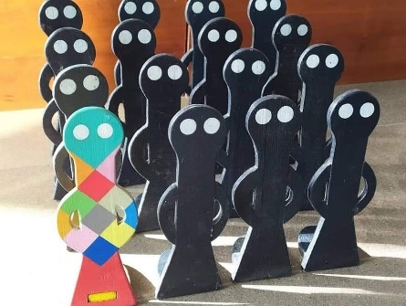

**MEMBERSHIP FORM**

The undersigned

Name and surname:

Address:

Profession:

Tel. Email:

Job title:

⬜**HEAD TEACHER**

⬜**TEACHER**

⬜ **PARENT**

⬜ **Other:**

**requests to join the journey of the Caravan of the Peaceful, which has been running since 2nd March 2015.**

**If you are organising any public initiatives or publishing posts on your websites/social media, it would be helpful if you could mention the official website** [**www.lacarovanadeipacifici.it**](http://www.lacarovanadeipacifici.it) **or our Facebook page** [**https://www.facebook.com/lacarovanadeipacifici**](https://www.facebook.com/lacarovanadeipacifici)

The documentation needs to be sent in digital format (short report; texts; photos; audio; video) to the address:

***carovanadeipacifici@gmail.com***

Date Signature:

**Agreement note:**

The **Brescia Montessori Association** undertakes to use the documentation materials (texts; photos; audio; video) sent only and exclusively for the initiatives related to the journey of the **Caravan of the Peaceful**, providing appropriate and complete information on the origin.

The compilation of this form is to be considered for information only and does not require any formal commitment.